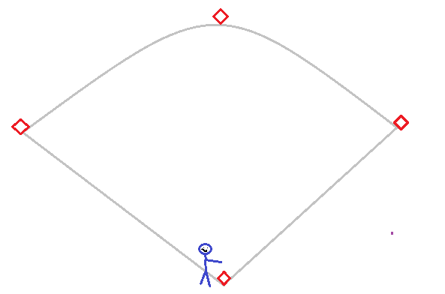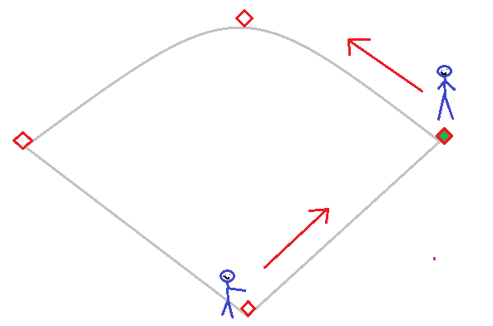

Force outs: 1B Force outs: 1B, 2B
Tag outs: None Tag outs: None

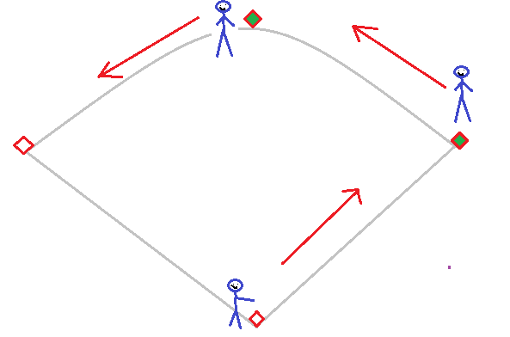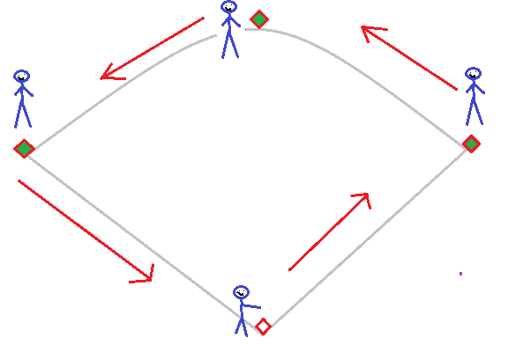

Force outs: 1B, 2B, 3B Force outs: 1B, 2B, 3B, Home
Tag outs: None Tag outs: None

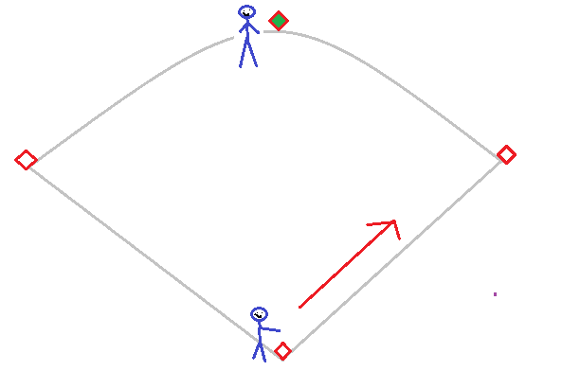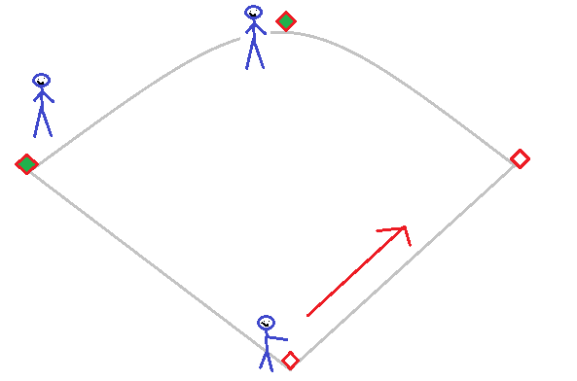

Force outs: 1B Force outs: 1B
Tag outs: Runner on 2B Tag outs: Runners on 2B and 3B

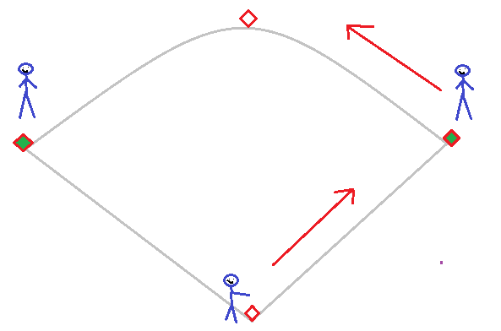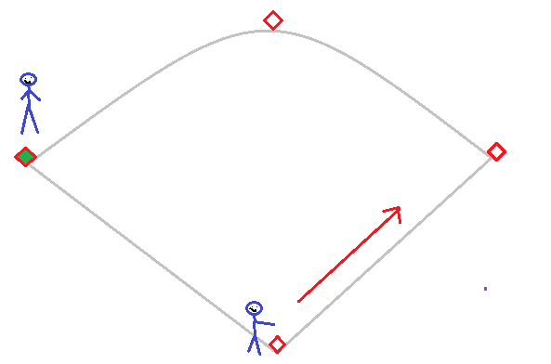

Force outs: 1B, 2B Force outs: 1B
Tag outs: Runner on 3B Tag outs: Runner on 3B

